How to write an abstract for the 2026 Shanghai International Symposium on Analytical Chemistry
Jin-Ming Lin, Jiangjiang Liu, Chuangsen Liu

Department of Chemistry, Tsinghua University, Beijing 100084, China.
Correspondence: jmlin@mail.tsinghua.edu.cn

This is an abstract template for the 2026 Shanghai International Symposium on Analytical Chemistry. The language of the abstracts is in English. To maintain a coherent layout of the proceedings, all authors should kindly write the abstracts using the templates provided in the conference web pages.
The template is designed to reproduce correctly when A4 paper and 3 cm margins are used. Please do not change these settings! The font should be Times New Roman 12pt. The users of OpenOffice should check that they have this font installed, since otherwise OpenOffice will silently substitute it with a similar, but alas incompatible, font.
Abstracts will be submitted to the organizer electronically. MS Word version is preferred. Using this template, your abstract must fit to one page, about 400 words.
In the list of authors, underline the name of the author responsible for the presentation of the paper. The abstract text should be justified. References are cited in the text like this [1]. The reference list should use the format shown at the bottom of the page.

You can also include figures in your abstract. Figure 1 shows the Opening & Plenary Session of the 8th Shanghai International Symposium on Analytical Chemistry.

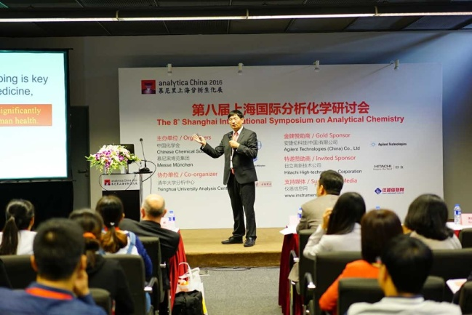
Figure 1: An example figure.

References
[1] J. Liu, H. Li, J.-M. Lin, Anal. Chem., 79: 371-377(2007).
[2] J. Liu, J.-M. Lin, D. Knopp, J. Micromech. Microeng., 18, 095014(2008).
[3] J. Liu, D. Gao, H. Li, J.-M. Lin, Lab Chip, 9, 1301-1305(2009).
[4] C. Liu, J. Liu, D. Gao, J.-M. Lin, Anal. Chem., 82, (2010), in press

